

Innovation (Tech Exports) in motivating countries' development
Ta Nguyen Quoc Thang VBC2TB

Project II - Applied Economics
[Budapest, 2024.5. ]

Introduction
Innovation is a key driver of economic development, with technology exports playing an important role in shaping a country's growth trajectory. This research project investigates the relationship between Technology Exports as a share of GDP and key indicators such as Education, R&D spending as a share of GDP, patent applications per million population, and overall GDP.
Previous literature has established the significance of technological advancement and education in fostering economic growth. For instance, higher school enrollment rates are often associated with a more skilled workforce capable of driving innovation. Similarly, R&D expenditure is a direct investment in innovation, leading to increased patent applications and technological developments that boost export performance. The integration of these factors creates a feedback loop where technological exports not only enhance GDP but also reinforce the innovation ecosystem through increased funding and resources. Traditionally, it was assumed that the export structure of countries depended on relative factor endowments, which led to more developed countries specializing in the production of more technology-intensive goods, relative factor endowments, which led to more developed countries specializing in the production of more technology-intensive goods, while less developed countries specializing in more resource-intensive and labor-intensive goods.
In this context, this research examines drivers of technology exports from 36 countries based on the data from the World Bank database, Our World of Data, and World Integrated Trade Solutions (WITS). The sample period considered is between 2013 and 2018. Therefore, a panel of 36 countries and 6 years is considered. The study aims to provide a comprehensive analysis by integrating multiple data sources and referencing existing research to understand how educational attainment, R&D activities, and patenting correlate with the economic benefits derived from technological exports. By examining these relationships across a diverse set of countries, we aim to offer insights that can inform policy decisions to enhance innovation-driven development.

Literature review
The literature on innovation and economic growth highlights the critical role of technological advancements in enhancing export performance. Navarro Zapata et al. (2023) identify key determinants of high-tech exports in OECD countries, emphasizing the importance of R&D expenditure, quality governance, and human capital. Silva, Styles, and Lages (2021) demonstrate that tech innovation positively impacts both economic and strategic export performance, particularly when supported by ample human resources and importer orientation. Conversely, market innovation has a more complex and often negative impact on strategic export performance. Botega and Romero (2021) further reinforce the significance of technological competitiveness over price competitiveness in driving export success, advocating for sustained investment in technology to maintain competitive advantages. These studies suggest that innovation-driven strategies are essential for boosting export performance and fostering long-term economic growth.

Data and Methodology
Data
Data from The World Bank and Our World in Data​ about 87 countries from 2007 to 2018 with 641 observations. However, data for the variables used are not available for all countries and all years; hence we chose the data from 36 countries covering 6 years (2013 to 2018).

Visualization
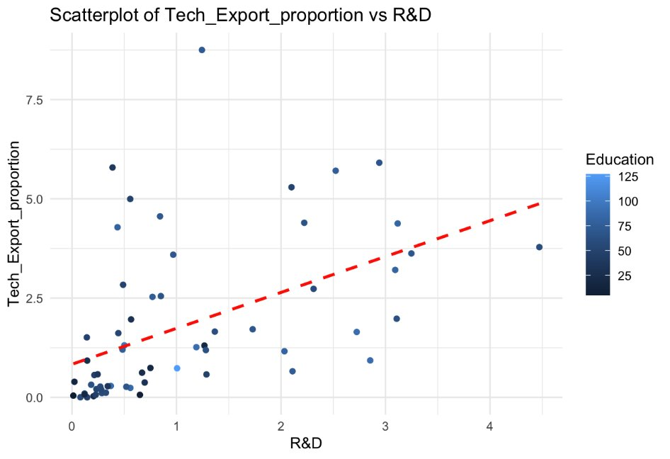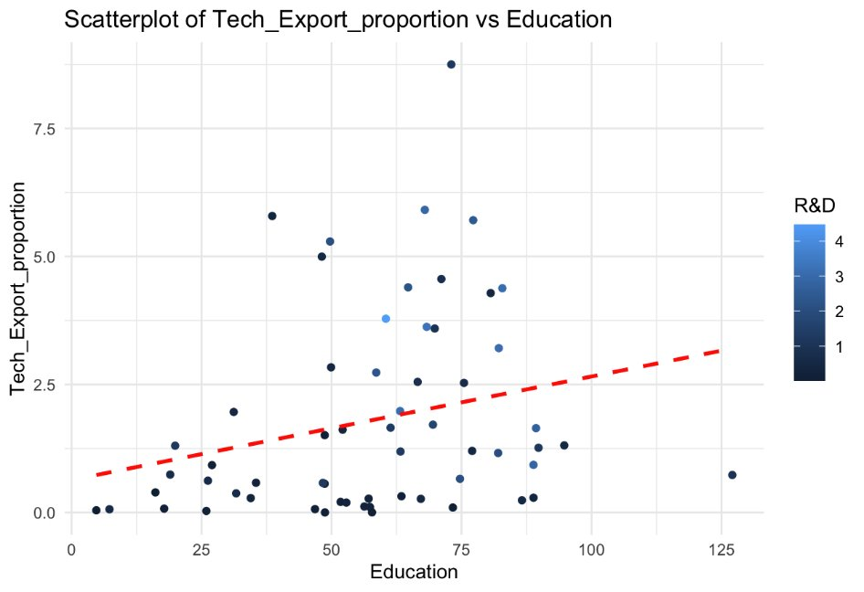

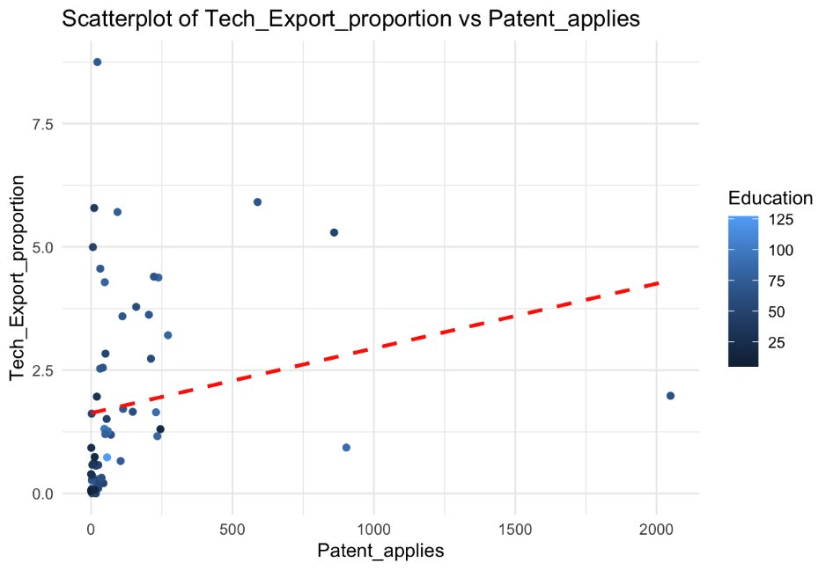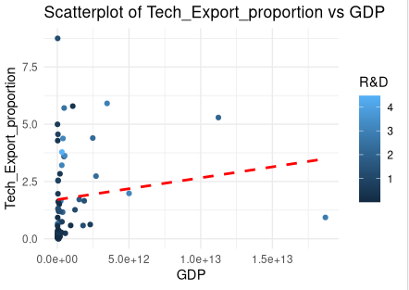

Graph 01 - Scatter plot of Tech Exports/GDP with other variables

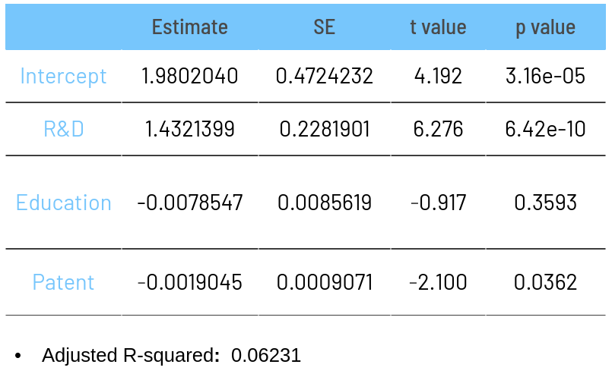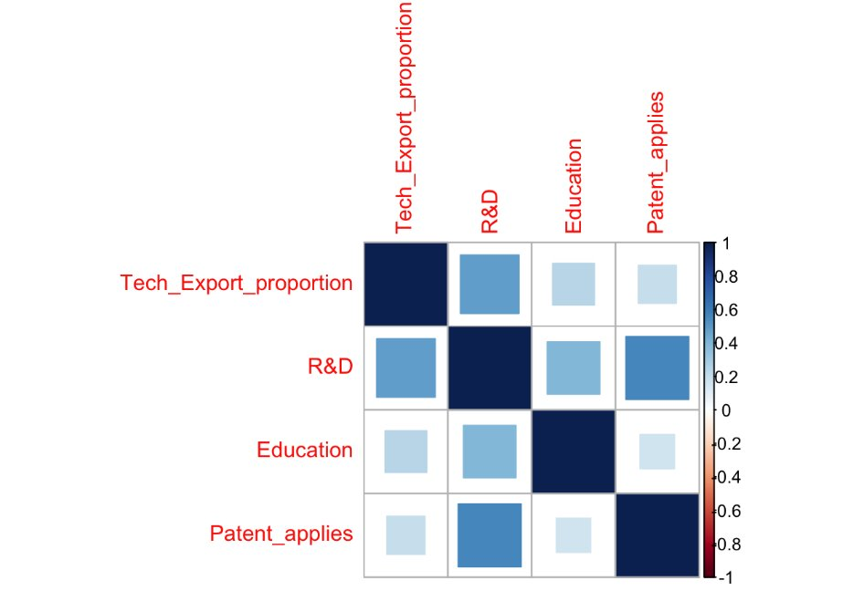
Table 01 - Base model and correlation matrix
Methodology
Cross-section panel analysis
We use a multivariate regression model to quantify the impact of R&D expenditure and patent applications on technological exports. The panel nature of the data allows us to control for country-specific effects and temporal dynamics, improving the robustness of our findings.
To ensure the reliability and validity of the model, we perform several diagnostic tests:
Variance Inflation Factor (VIF):
VIF is used to detect multicollinearity among the independent variables. A VIF value above 10 indicates high multicollinearity, warranting further investigation or model adjustment model
Model fit - Akaike Information Criterion (AIC):
AIC is used to assess the model's goodness of fit. It provides a measure of the relative quality of statistical models for a given set of data. The final model was selected based on the lowest AIC value, ensuring a balance between model complexity and explanatory power.
Therefore we can use the final model to provide a robust analysis of the factors influencing technological exports as the proportion of GDP on R&D, Patent application, and Education.
Result
VIF Variance Inflation Factor
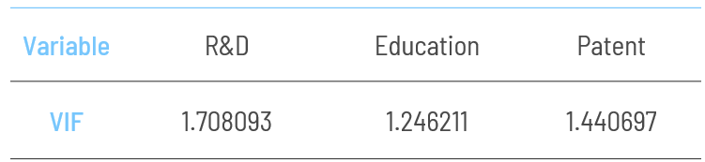
Table 02 - VIF
In our model, VIF values for R&D and Patents are below the threshold, indicating that multicollinearity is not a significant concern.
Model Fit - AIC
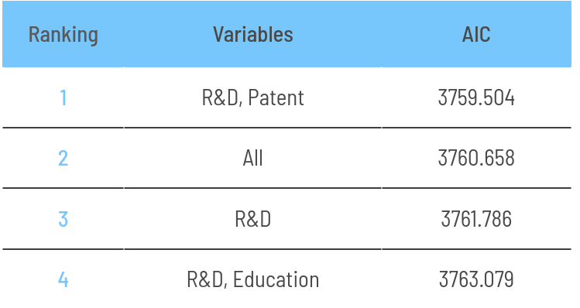
Table 03 - AIC
New models
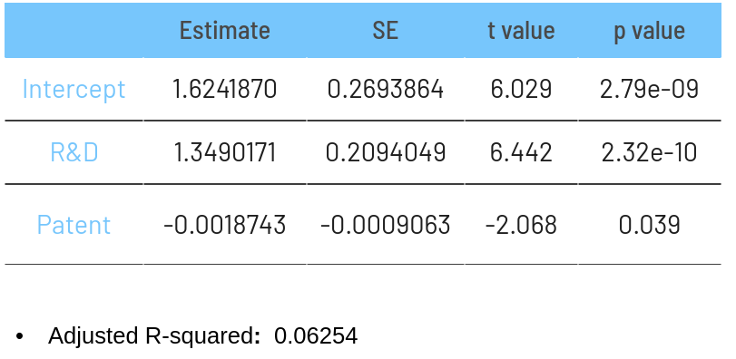
Table 04 - Final model
Multivariate Regression with R&D and Patent:​
(Tech_Export) = 1.6241870 + 1.3490171(R&D) - 0.0018743​(Patent)
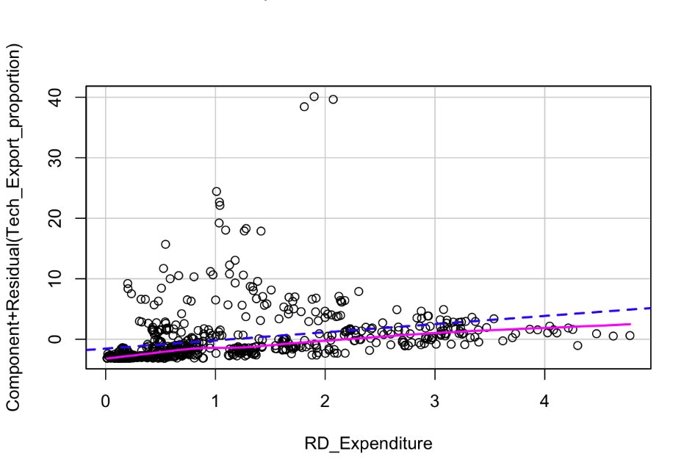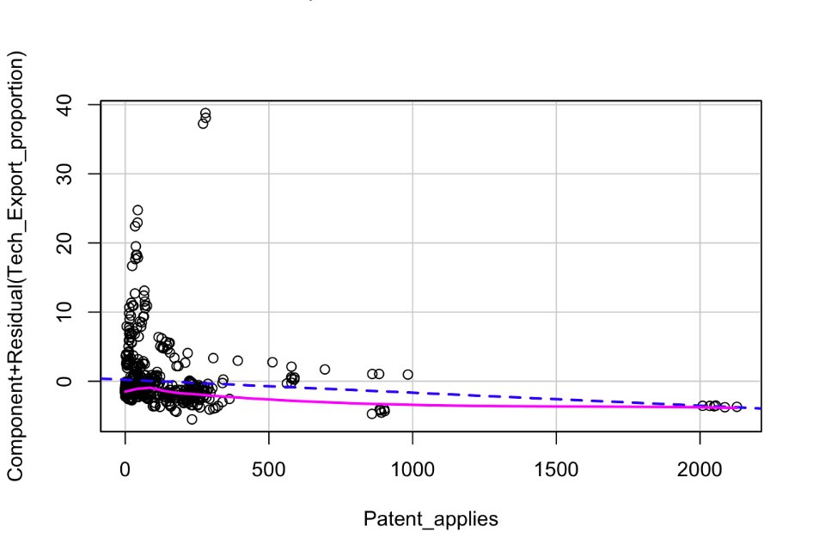

Interpretation
The regression results of “Table 04 - Final model” provide valuable insights into the relationship between technological exports (as a share of GDP) and key innovation indicators such as R&D expenditure and patent applications.
The intercept of 1.6241870 indicates the expected value of technological exports when R&D expenditure and patent applications are zero. While this value is not directly interpretable in practical terms, it serves as the baseline level of tech exports.
R&D expenditure has a highly significant positive impact on technological exports. The low p-value (< 0.001) indicates strong statistical significance, and the large coefficient (1.3490171) suggests that for each one-unit increase in R&D expenditure (as a percentage of GDP), technological exports are predicted to increase by approximately 1.349 units. This finding underscores the critical role of R&D in driving technological exports and, consequently, economic development.
Patent applications (as the number of patent applications over one million population) have a slightly negative impact on technological exports, with a coefficient of -0.0018743. Although this effect is statistically significant (p-value < 0.05), its magnitude is relatively small. The negative coefficient suggests that an increase in patent applications is associated with a marginal decrease in technological exports. This counterintuitive result could be attributed to various factors, such as the quality of patents or the time lag between patent filing and commercialization.
The adjusted R-squared value of 0.06254 indicates that approximately 6.25% of the variability in technological exports is explained by the model, including R&D expenditure and patent applications. This value suggests a modest explanatory power, highlighting the importance of considering additional factors or potential model refinements to better capture the dynamics of technological exports.
Comparison with Other Models
A model including only R&D expenditure and patent applications yields an adjusted R-squared of 0.06254, slightly higher than a model that might include additional variables such as education. This slight improvement (from 0.06231 to 0.06254) suggests that R&D expenditure and patent applications are the most pertinent predictors among the considered variables, but also indicates that there is room for enhancing the model's explanatory power by exploring other relevant factors.

Conclusion
The analysis reveals that R&D expenditure is the most significant determinant of technological exports, with a substantial positive effect. While patent applications are also significant, their negative coefficient and smaller magnitude suggest a more complex relationship that warrants further investigation. The modest adjusted R-squared value indicates that additional variables and factors should be explored to build a more comprehensive model of technological exports. This study provides a foundational understanding of the key drivers of tech exports and highlights the importance of sustained investment in R&D for economic development.

Weakness and Further research
Limited Explanatory Power:
The adjusted R-squared value of 0.06254 indicates that the model explains only about 6.25% of the variability in technological exports. This suggests that there are many other factors influencing tech exports that are not captured by our model. Key variables such as market size, economic policies, infrastructure quality, and innovation ecosystems might play significant roles and were not included in our analysis.
Data Limitations:
The study relies on data from 36 countries over the period 2013-2018. This sample size, while informative, may not fully capture the global diversity of economic and innovation environments. Additionally, the time frame might be insufficient to observe long-term trends and the impact of R&D and patent applications on tech exports.
Simplified Assumptions:
The model assumes a linear relationship between R&D expenditure, patent applications, and technological exports. However, the dynamics of innovation and exports are likely more complex, involving nonlinear interactions, feedback loops, and time lags that our model does not account for.
Further research
Future research should include a broader set of variables, such as market size, infrastructure quality, economic policies, and educational quality, to better capture the determinants of technological exports. For future research, applying the Box-Jenkins method (ARIMA models) could be beneficial to understanding the time-dependent nature of technological exports. This method could help identify and model underlying patterns, seasonal effects, and other temporal dynamics that influence tech exports. Using ARIMA models would allow for better forecasting and more precise policy recommendations. This would enhance the explanatory power and robustness of the model.

Data Availability
Data for the analysis of the drivers of exports of technology-intensive manufactures come from the World Bank database, Ourworldindata, and The World Integrated Trade Solution (WITS) database:
https://databank.worldbank.org/, https://ourworldindata.org/, https://wits.worldbank.org/
1, Tech export: https://data.worldbank.org/indicator/TX.VAL.TECH.CD?end=2022&start=2007&view=chart
2, School enrollment: https://data.worldbank.org/indicator/SE.TER.ENRR
3, R&D:https://data.worldbank.org/indicator/GB.XPD.RSDV.GD.ZS
4, Annual patent application per millions of people https://ourworldindata.org/grapher/patent-applications-per-million?tab=table
5, GDP By Country, in current US$ 1988-2021 https://wits.worldbank.org/CountryProfile/en/country/by-country/startyear/ltst/endyear/ltst/indicator/NY-GDP-MKTP-CD

References
1, Amadeo Navarro Zapata, María Arrazola, José de Hevia (2023). “Determinants of High-tech Exports: New Evidence from OECD Countries”. Journal of the Knowledge Economy, https://link.springer.com/content/pdf/10.1007/s13132-023-01116-z.pdf
2, Graca Miranda Silva, Chris Styles, Luis Filipe Lages (2021). “Breakthrough Innovation in International Business: The Impact of tech-innovation and market-innovation on Performance”.International Business Review, https://doi.org/10.1016/j.ibusrev.2016.10.001
3, Anna Botega, Joan Romero (2021). “Innovation, export performance, and trade elasticities across different sectors”. Structural Change and Economic Dynamics, https://doi.org/10.1016/j.strueco.2021.05.008

